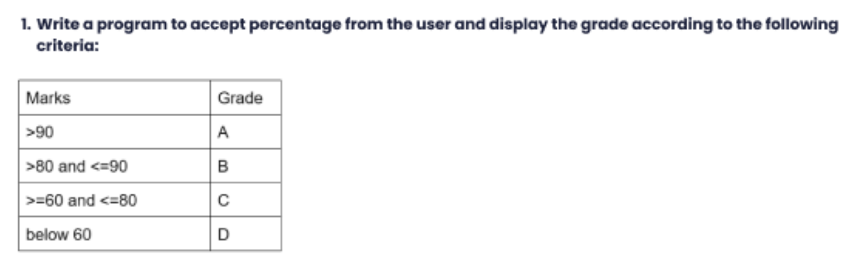

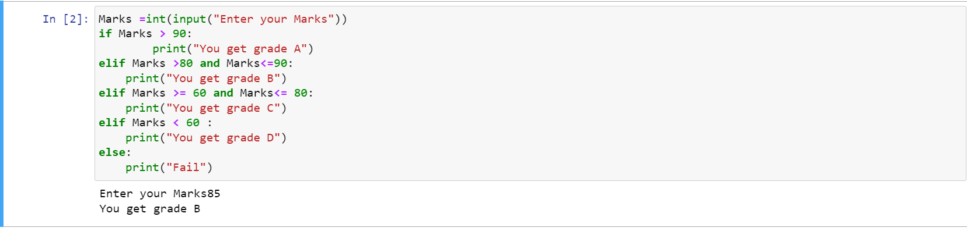

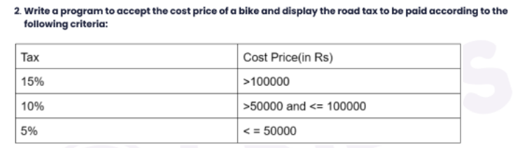

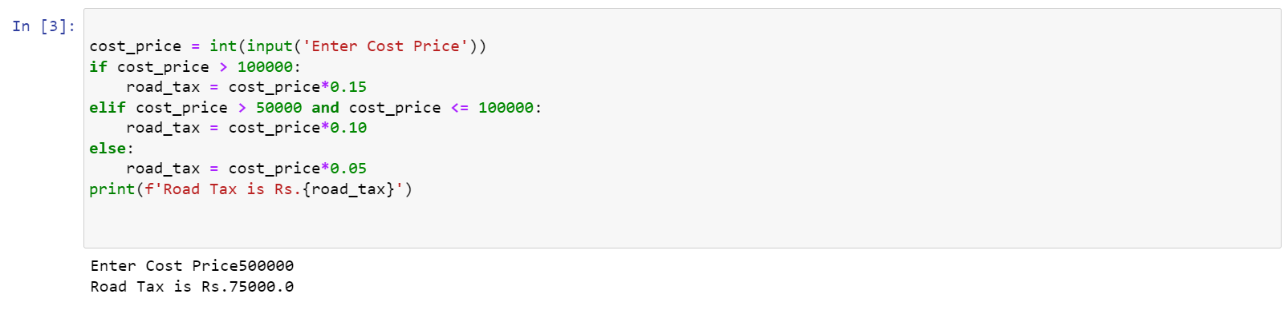

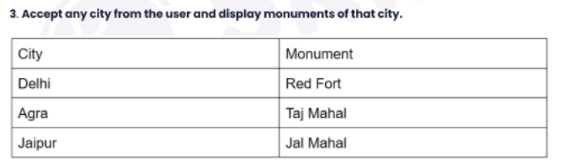

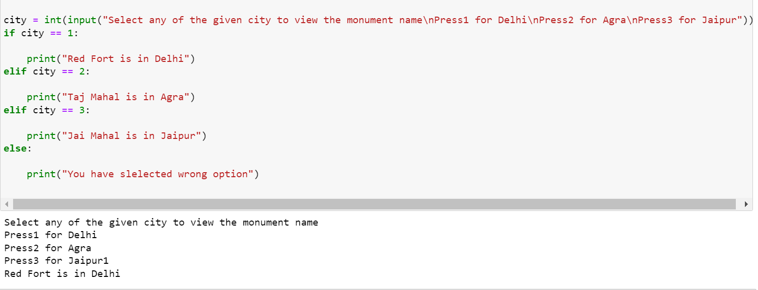



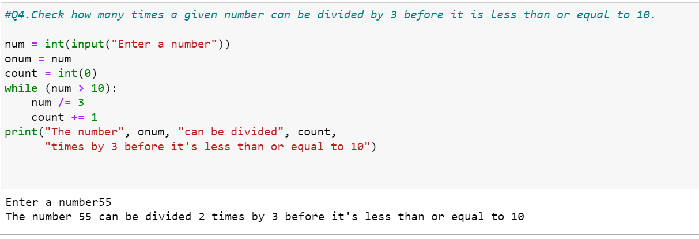



While loop is used when we have to stop/start executing some codes only when some condition(s) is/are fulfilled. e.g. 'Count from 1 to 15' - Here the condition is to start from int 1 and keep executing until the counter doesn't reach 15 or in other words keep executing from 1 to till the counter is less than 16.



